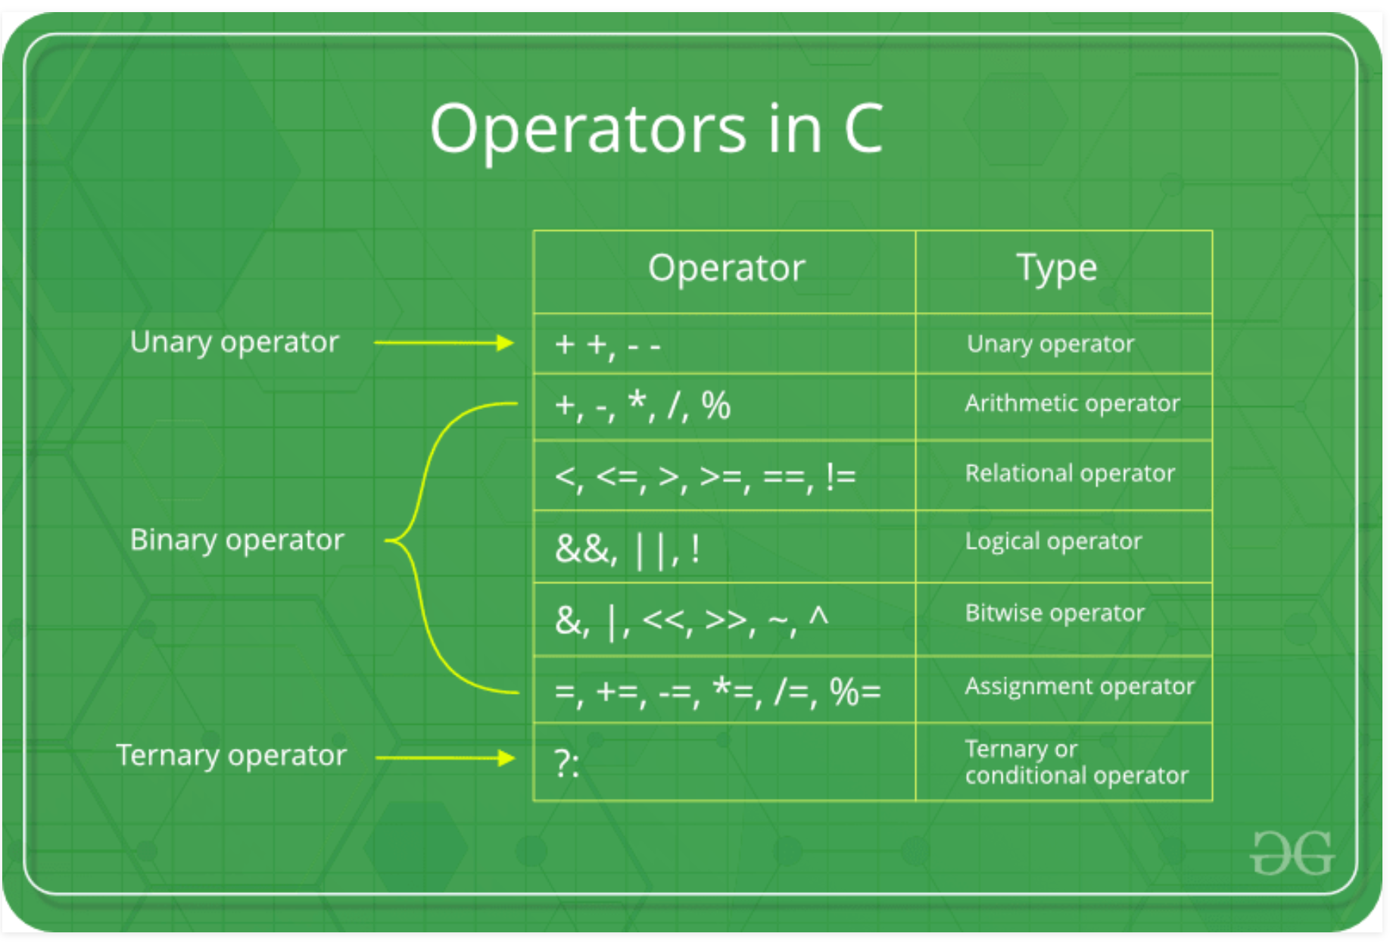

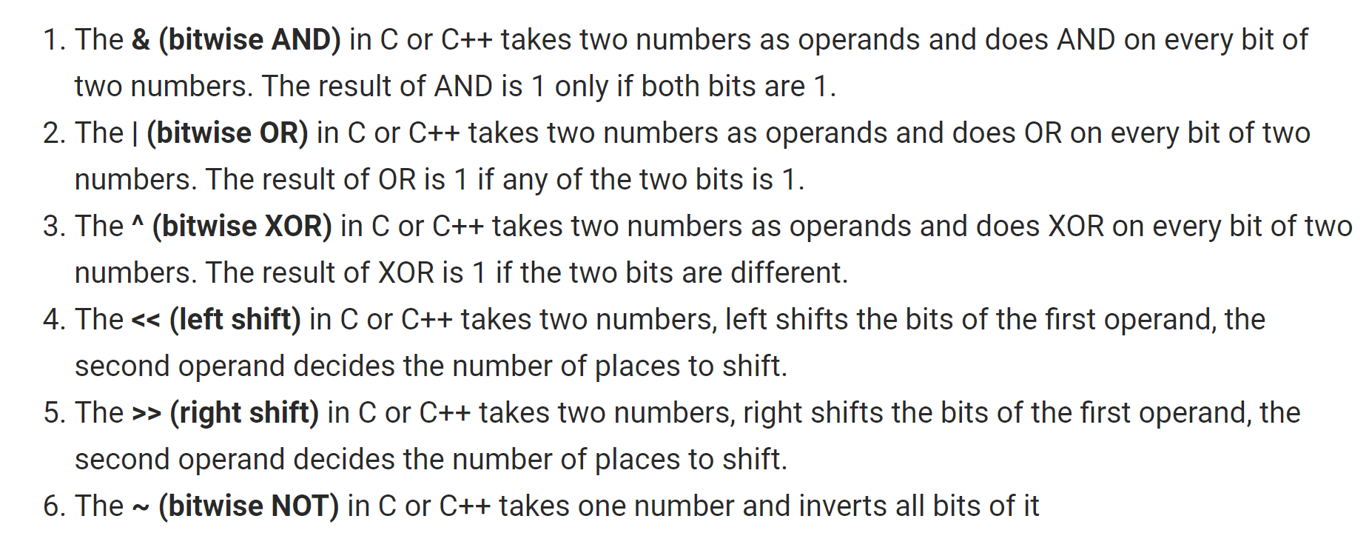

Write a C program to input any number and check whether the given number is even or odd using bitwise operator. How to check whether a number is even or odd using bitwise operator in C programming. Logic to check even odd using bitwise operator in C programming.

**Example**

**Input**

Input number: 12

**Output**

12 is even

Ans:

/**

* C program to check even or odd number using bitwise operator

*/

#include <stdio.h>

int main()

{

int num;

/* Input number from user */

printf("Enter any number: ");

scanf("%d", &num);

if(num & 1)

{

printf("%d is odd.", num);

}

else

{

printf("%d is even.", num);

}

return 0;

}

**The statement if(num & 1) is equivalent to if((num & 1) == 1).**

**Program to check even or odd using conditional and bitwise operator**

/**

* C program to check whether a number is even or odd using bitwise operator

*/

#include <stdio.h>

int main()

{

int num;

/* Input number from user */

printf("Enter any number: ");

scanf("%d", &num);

(num & 1)

? printf("%d is odd.", num)

: printf("%d is even.", num);

return 0;

}

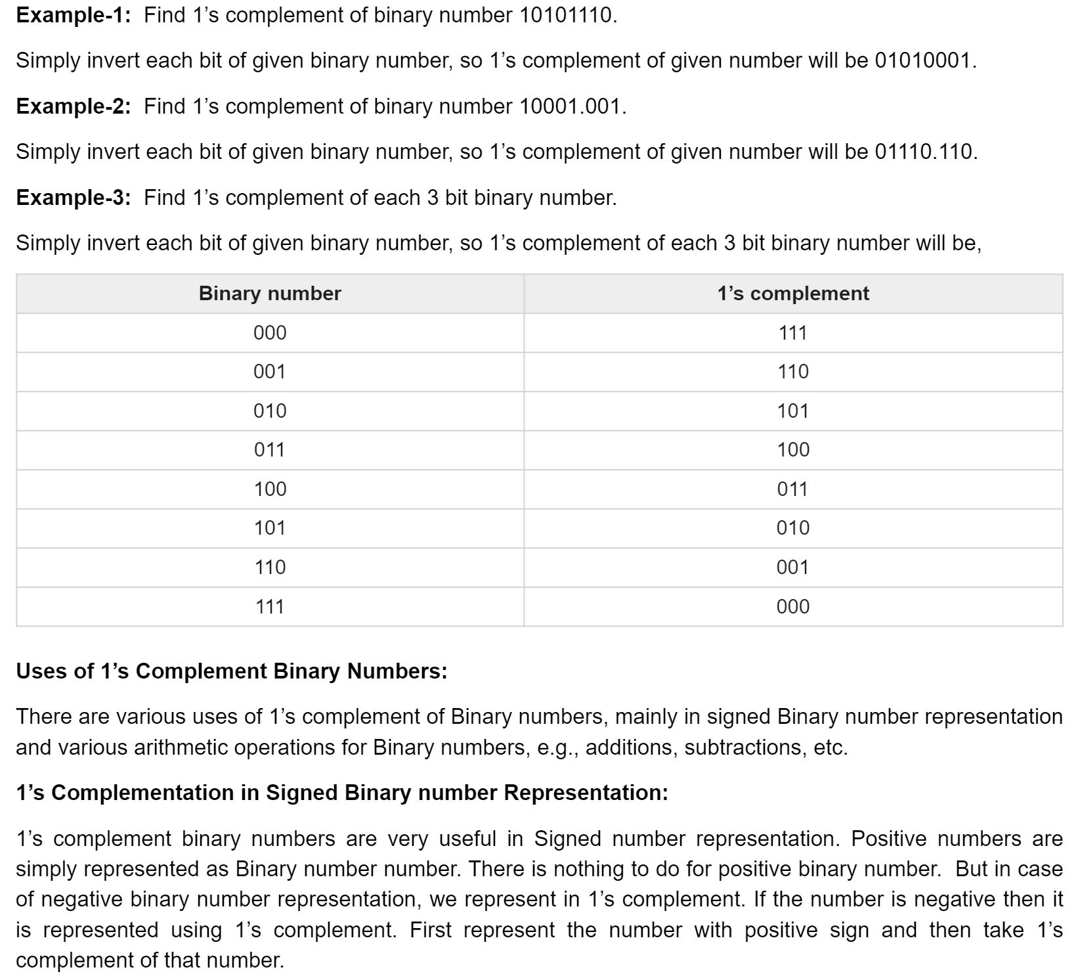

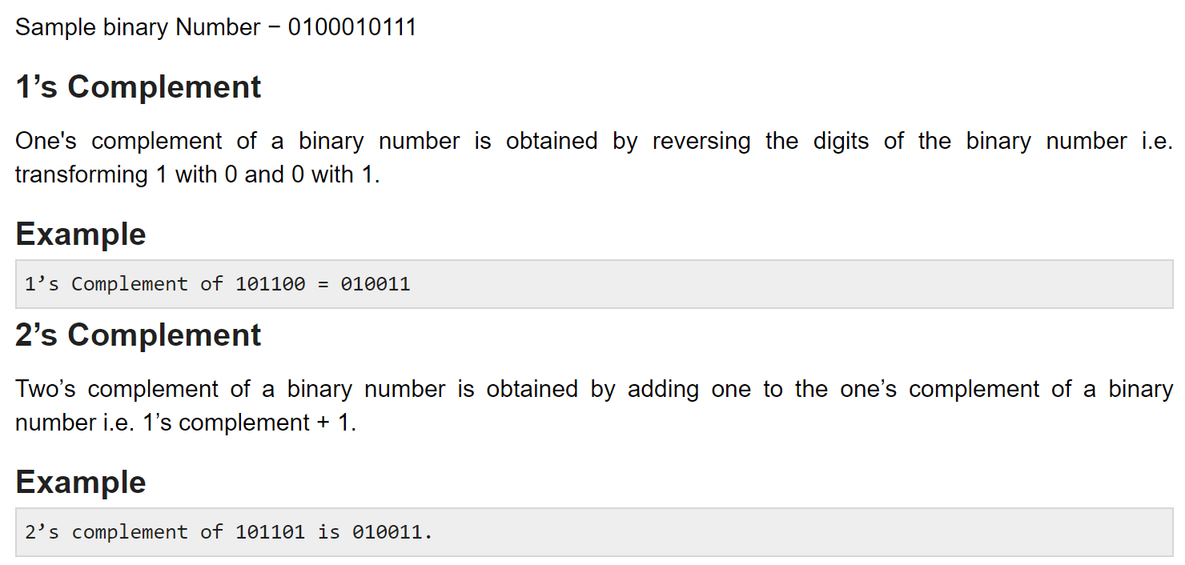

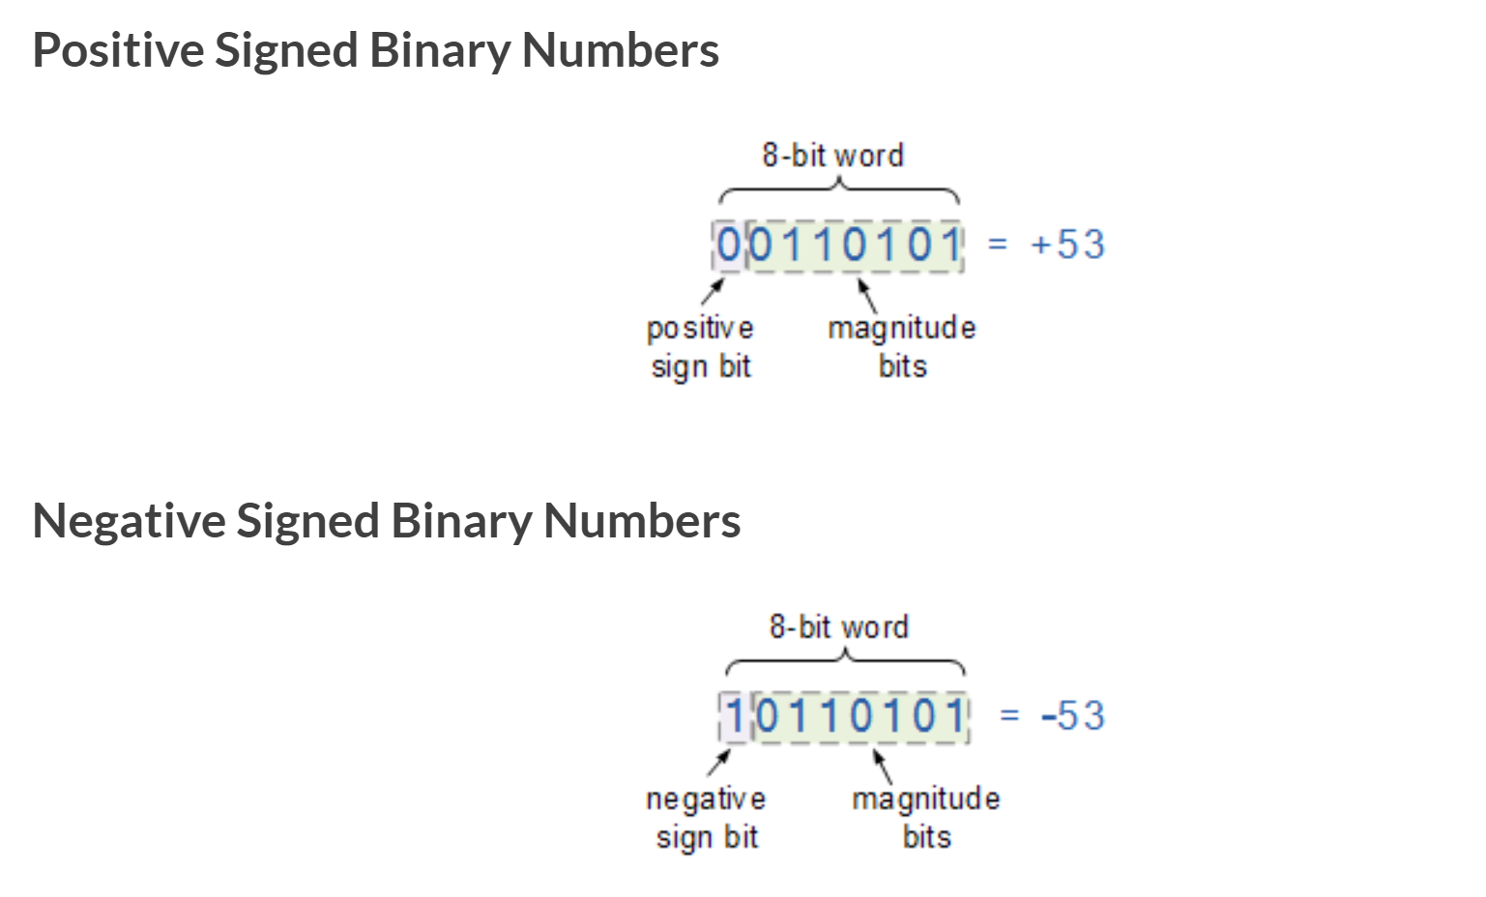

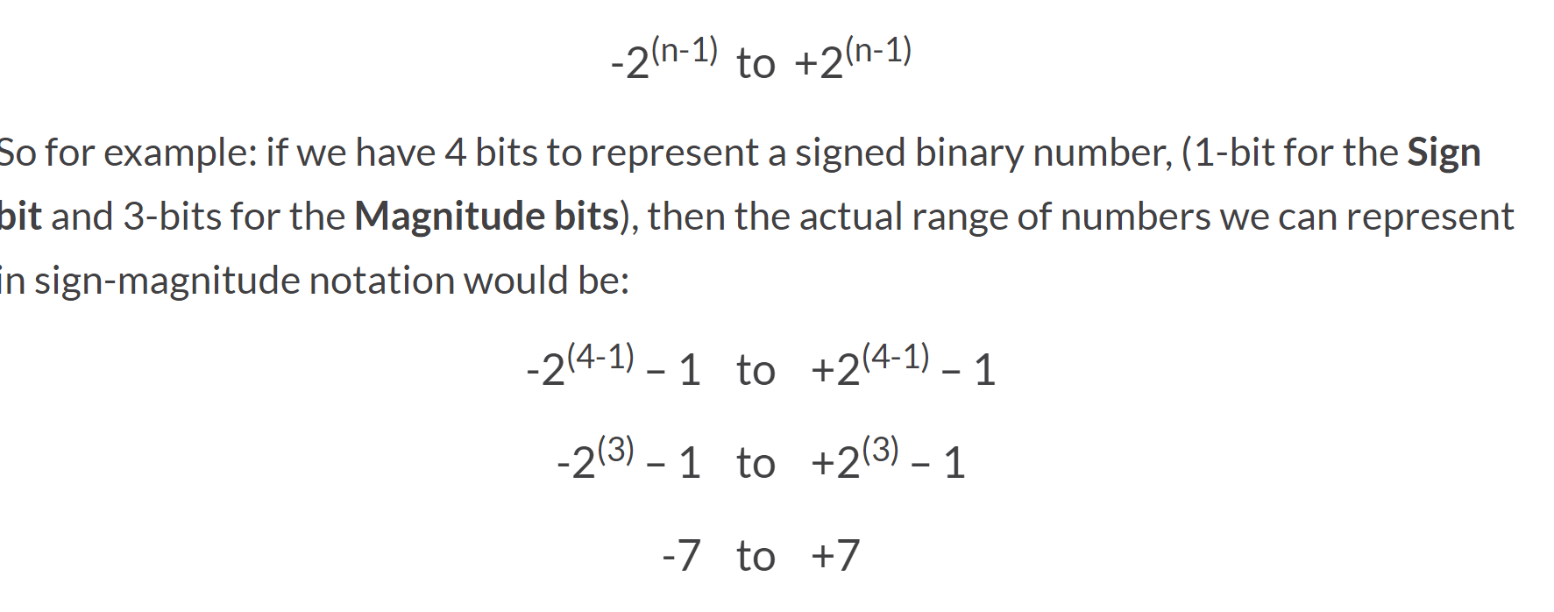

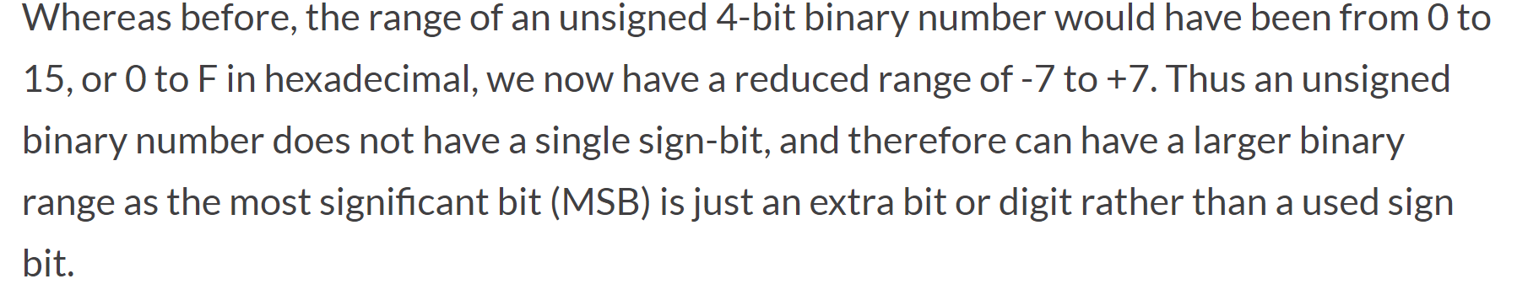

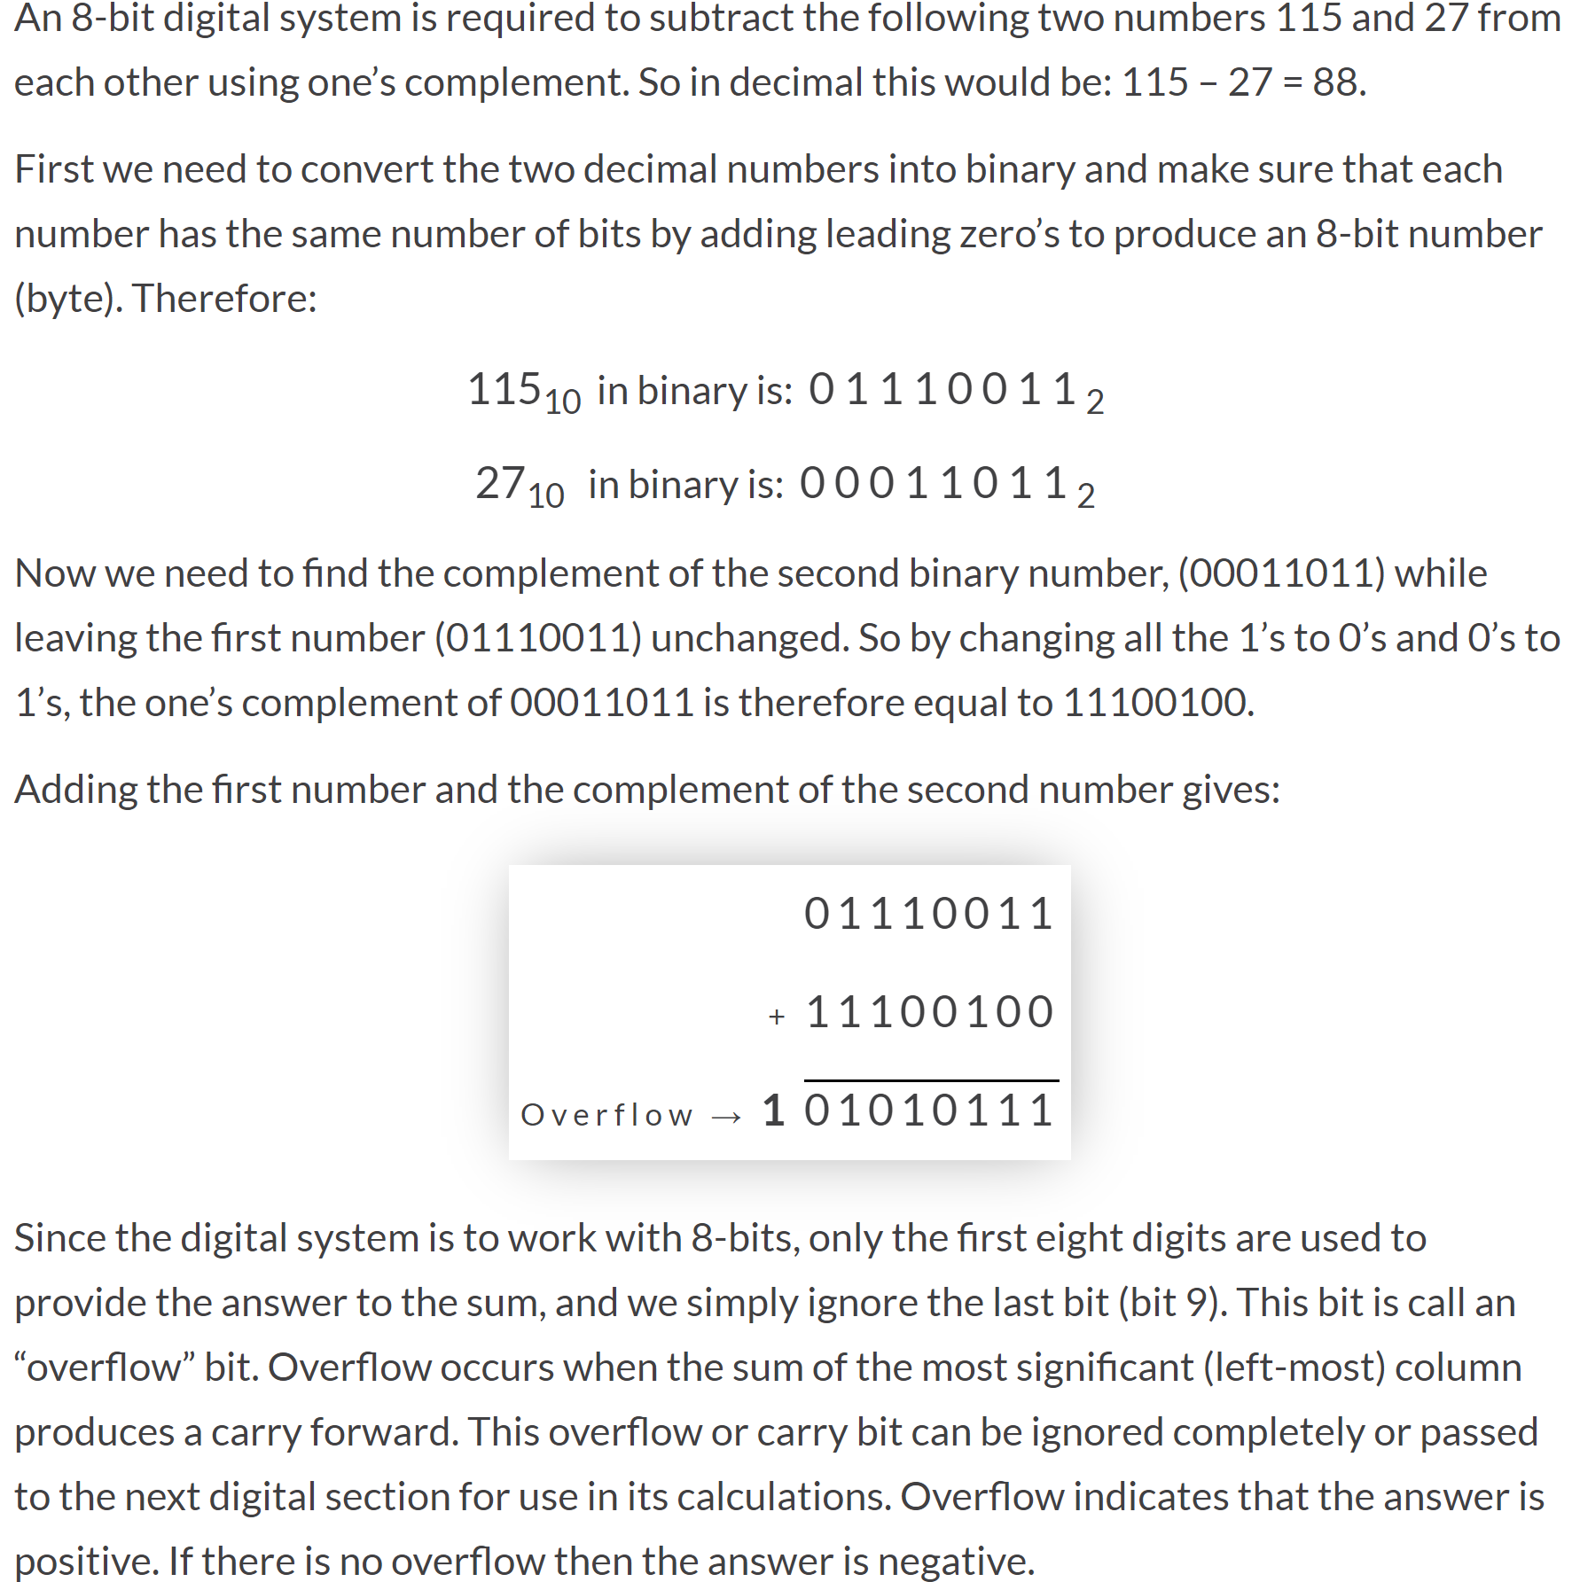

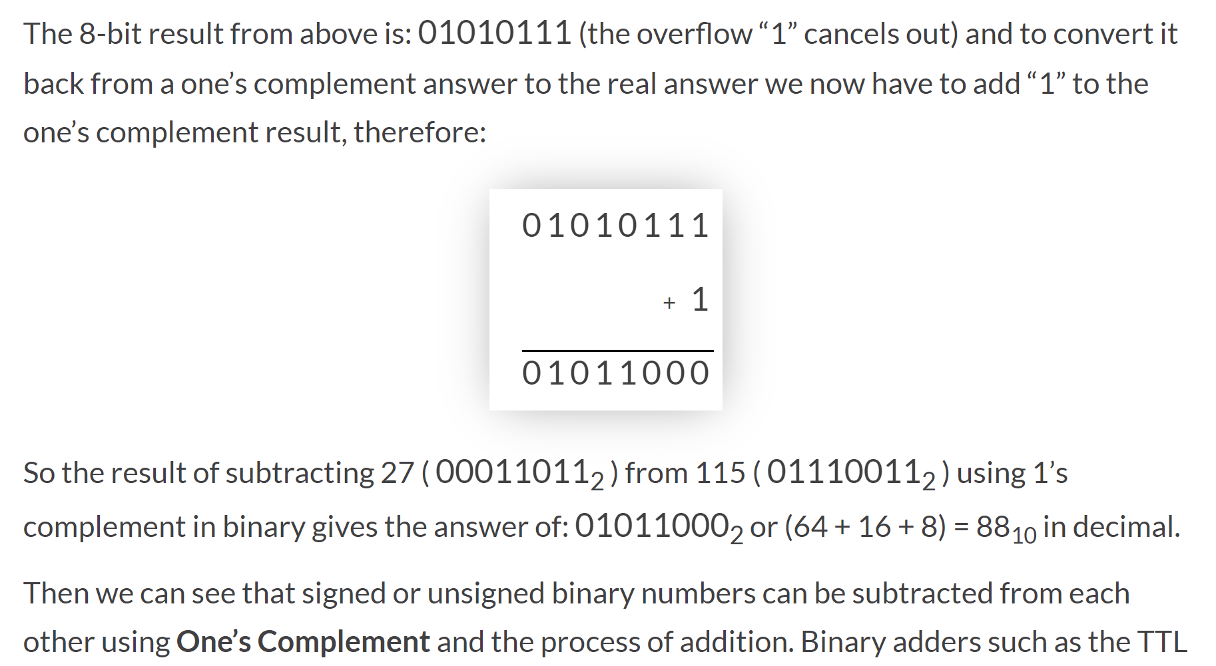

**2’s Complement**

A – B = A + ( 2’s complement of B )

**two’s complement is one’s complement + 1.**